***AndroidManifest.xml***

<?xml version="1.0" encoding="utf-8"?>  
<manifest xmlns:android="http://schemas.android.com/apk/res/android"  
 xmlns:tools="http://schemas.android.com/tools">  
 <application  
 android:allowBackup="true"  
 android:dataExtractionRules="@xml/data_extraction_rules"  
 android:fullBackupContent="@xml/backup_rules"  
 android:icon="@mipmap/ic_launcher"  
 android:label="@string/app_name"  
 android:roundIcon="@mipmap/ic_launcher_round"  
 android:supportsRtl="true"  
 android:theme="@style/Theme. btbuoi4">  
  
 <!-- MainActivity -->  
 <activity  
 android:name=".MainActivity"  
 android:exported="true">  
 <intent-filter>  
 <action android:name="android.intent.action.MAIN" />  
 <category android:name="android.intent.category.LAUNCHER" />  
 </intent-filter>  
 </activity>  
  
 <!-- Thêm HelloActivity -->  
 <activity  
 android:name=".HelloActivity"  
 android:exported="false" />  
  
 <!-- Thêm RegisterActivity -->  
 <activity  
 android:name=".RegisterActivity"  
 android:exported="false" />  
  
 </application>  
  
  
</manifest>

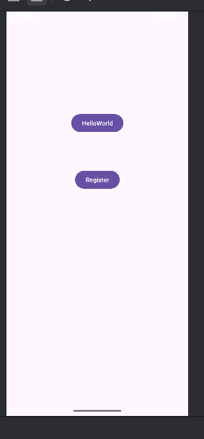

***Tạo HelloActivity.java***

package com.example. btbuoi4;   
import androidx.appcompat.app.AppCompatActivity;  
import android.os.Bundle;  
  
public class HelloActivity extends AppCompatActivity {  
  
 @Override  
 protected void onCreate(Bundle savedInstanceState) {  
 super.onCreate(savedInstanceState);  
 setContentView(R.layout.*activity_hello*); // gắn với giao diện activity_hello.xml  
 }  
}

***activity_hello_xml:***

<?xml version="1.0" encoding="utf-8"?>  
<androidx.constraintlayout.widget.ConstraintLayout xmlns:android="http://schemas.android.com/apk/res/android"  
 xmlns:app="http://schemas.android.com/apk/res-auto"  
 xmlns:tools="http://schemas.android.com/tools"  
 android:layout_width="match_parent"  
 android:layout_height="match_parent"  
 tools:context=".HelloActivity">  
  
 <TextView  
 android:id="@+id/tvHello"  
 android:layout_width="wrap_content"  
 android:layout_height="wrap_content"  
 android:text="Hello World!"  
 android:textSize="24sp"  
 app:layout_constraintBottom_toBottomOf="parent"  
 app:layout_constraintEnd_toEndOf="parent"  
 app:layout_constraintStart_toStartOf="parent"  
 app:layout_constraintTop_toTopOf="parent" />  
</androidx.constraintlayout.widget.ConstraintLayout>

***RegisterActivity.java***

package com.example. btbuoi4;  
import androidx.appcompat.app.AppCompatActivity;  
import android.os.Bundle;  
import android.widget.Button;  
import android.widget.EditText;  
import android.widget.Toast;  
  
public class RegisterActivity extends AppCompatActivity {  
  
 @Override  
 protected void onCreate(Bundle savedInstanceState) {  
 super.onCreate(savedInstanceState);  
 setContentView(R.layout.*activity_register*);  
  
 EditText edtName = findViewById(R.id.*edtName*);  
 Button btnSubmit = findViewById(R.id.*btnSubmit*);  
  
 btnSubmit.setOnClickListener(v -> {  
 String name = edtName.getText().toString();  
 Toast.*makeText*(this, "Welcome " + name, Toast.*LENGTH_SHORT*).show();  
 });  
 }  
}

***activity_register_xml:***

<?xml version="1.0" encoding="utf-8"?>  
<androidx.constraintlayout.widget.ConstraintLayout xmlns:android="http://schemas.android.com/apk/res/android"  
 xmlns:app="http://schemas.android.com/apk/res-auto"  
 xmlns:tools="http://schemas.android.com/tools"  
 android:layout_width="match_parent"  
 android:layout_height="match_parent"  
 tools:context=".RegisterActivity">  
  
 <EditText  
 android:id="@+id/edtName"  
 android:layout_width="0dp"  
 android:layout_height="wrap_content"  
 android:hint="Enter your name"  
 app:layout_constraintTop_toTopOf="parent"  
 app:layout_constraintStart_toStartOf="parent"  
 app:layout_constraintEnd_toEndOf="parent"  
 android:layout_margin="16dp"/>  
  
 <Button  
 android:id="@+id/btnSubmit"  
 android:layout_width="wrap_content"  
 android:layout_height="wrap_content"  
 android:text="Register"  
 app:layout_constraintTop_toBottomOf="@+id/edtName"  
 app:layout_constraintStart_toStartOf="parent"  
 app:layout_constraintEnd_toEndOf="parent"  
 android:layout_marginTop="16dp"/>  
</androidx.constraintlayout.widget.ConstraintLayout>

***MainActivity.java***

package com.example. btbuoi4;  
  
import android.os.Bundle;  
import androidx.appcompat.app.AppCompatActivity;  
import android.os.Bundle;  
import android.view.View;  
import android.content.Intent;  
import androidx.activity.EdgeToEdge;  
import androidx.appcompat.app.AppCompatActivity;  
import androidx.core.graphics.Insets;  
import androidx.core.view.ViewCompat;  
import androidx.core.view.WindowInsetsCompat;  
public class MainActivity extends AppCompatActivity {  
  
 @Override  
 protected void onCreate(Bundle savedInstanceState) {  
 super.onCreate(savedInstanceState);  
 setContentView(R.layout.*activity_main*);  
 }  
  
 // Khi bấm nút HelloWorld  
 public void onBtnHelloClick(View view) {  
 Intent intent = new Intent(this, HelloActivity.class);  
 startActivity(intent);  
 }  
  
 // Khi bấm nút Register  
 public void onBtnRegisterClick(View view) {  
 Intent intent = new Intent(this, RegisterActivity.class);  
 startActivity(intent);  
 }  
}

***activity_main_xml***

<?xml version="1.0" encoding="utf-8"?>  
<androidx.constraintlayout.widget.ConstraintLayout xmlns:android="http://schemas.android.com/apk/res/android"  
 xmlns:app="http://schemas.android.com/apk/res-auto"  
 xmlns:tools="http://schemas.android.com/tools"  
 android:id="@+id/main"  
 android:layout_width="match_parent"  
 android:layout_height="match_parent"  
 tools:context=".MainActivity">  
  
 <!-- Nút HelloWorld -->  
 <Button  
 android:id="@+id/btnHelloWorld"  
 android:layout_width="wrap_content"  
 android:layout_height="wrap_content"  
 android:layout_marginTop="228dp"  
 android:onClick="onBtnHelloClick"  
 android:text="HelloWorld"  
 app:layout_constraintEnd_toEndOf="parent"  
 app:layout_constraintStart_toStartOf="parent"  
 app:layout_constraintTop_toTopOf="parent" />  
  
 <!-- Nút Register -->  
 <Button  
 android:id="@+id/btnRegister"  
 android:layout_width="wrap_content"  
 android:layout_height="wrap_content"  
 android:layout_marginTop="80dp"  
 android:onClick="onBtnRegisterClick"  
 android:text="Register"  
 app:layout_constraintEnd_toEndOf="parent"  
 app:layout_constraintStart_toStartOf="parent"  
 app:layout_constraintTop_toBottomOf="@+id/btnHelloWorld" />  
</androidx.constraintlayout.widget.ConstraintLayout>

***SmsActivity.java***

package com.example. btbuoi4;  
  
import androidx.appcompat.app.AppCompatActivity;  
import android.os.Bundle;  
import android.widget.TextView;  
import android.widget.Toast;  
import android.content.Intent;  
import android.content.IntentFilter;  
import android.content.BroadcastReceiver;  
import android.content.Context;  
import android.telephony.SmsMessage;  
import android.provider.Telephony;  
import android.text.TextUtils;  
import android.Manifest;  
import android.content.pm.PackageManager;  
import androidx.core.app.ActivityCompat;  
import androidx.core.content.ContextCompat;  
import java.util.ArrayList;  
  
public class SmsActivity extends AppCompatActivity {  
 private BroadcastReceiver smsReceiver;  
 private TextView tvContent;  
  
 @Override  
 protected void onCreate(Bundle savedInstanceState) {  
 super.onCreate(savedInstanceState);  
 setContentView(R.layout.*activity_sms*);  
  
 tvContent = findViewById(R.id.*tv_content*);  
 // 🔹 Xin quyền RECEIVE_SMS lúc runtime  
 if (ContextCompat.*checkSelfPermission*(this, Manifest.permission.*RECEIVE_SMS*)  
 != PackageManager.*PERMISSION_GRANTED*) {  
 ActivityCompat.*requestPermissions*(this,  
 new String[]{Manifest.permission.*RECEIVE_SMS*}, 100);  
 }  
  
 initBroadcastReceiver();  
 initBroadcastReceiver();  
 }  
  
 private void initBroadcastReceiver() {  
 smsReceiver = new BroadcastReceiver() {  
 @Override  
 public void onReceive(Context context, Intent intent) {  
 // Lấy tin nhắn từ intent  
 SmsMessage[] messages = Telephony.Sms.Intents.*getMessagesFromIntent*(intent);  
 StringBuilder body = new StringBuilder();  
 ArrayList<String> from = new ArrayList<>();  
  
 for (SmsMessage m : messages) {  
 from.add(m.getOriginatingAddress());  
 body.append(m.getMessageBody());  
 }  
  
 // Hiển thị tin nhắn  
 tvContent.setText("From: " + TextUtils.*join*(", ", from) + "\n" + body.toString());  
 Toast.*makeText*(context, "Bạn có tin nhắn mới!", Toast.*LENGTH_SHORT*).show();  
 }  
 };  
 }  
  
 @Override  
 protected void onResume() {  
 super.onResume();  
 // Đăng ký Receiver khi Activity chạy  
 registerReceiver(smsReceiver, new IntentFilter(Telephony.Sms.Intents.*SMS_RECEIVED_ACTION*));  
 }  
  
 @Override  
 protected void onStop() {  
 super.onStop();  
 // Hủy đăng ký khi Activity dừng  
 unregisterReceiver(smsReceiver);  
 }  
}

***activity_sms_.xml***

<?xml version="1.0" encoding="utf-8"?>  
<LinearLayout xmlns:android="http://schemas.android.com/apk/res/android"  
 xmlns:tools="http://schemas.android.com/tools"  
 android:layout_width="match_parent"  
 android:layout_height="match_parent"  
 android:orientation="vertical"  
 android:padding="8dp"  
 tools:context=".SmsActivity">  
  
 <TextView  
 android:id="@+id/tv_content"  
 android:layout_width="match_parent"  
 android:layout_height="wrap_content"  
 android:text="Chưa có tin nhắn"  
 android:textSize="18sp"  
 android:padding="8dp"/>  
</LinearLayout>

***Thêm code Manifest:***

<activity  
 android:name=".SmsActivity"  
 android:exported="false" />  
<activity android:name=".PowerActivity" android:exported="false"/>

***Test tính năng nhận SMS***

***Tạo PowerStateChangeReceiver.java***

package com.example.btbuoi4;  
  
import android.content.BroadcastReceiver;  
import android.content.Context;  
import android.content.Intent;  
import android.widget.Toast;  
  
public class PowerStateChangeReceiver extends BroadcastReceiver {  
 @Override  
 public void onReceive(Context context, Intent intent) {  
 String action = intent.getAction();  
  
 if (Intent.*ACTION_POWER_CONNECTED*.equals(action)) {  
 Toast.*makeText*(context, "Power connected", Toast.*LENGTH_SHORT*).show();  
 } else if (Intent.*ACTION_POWER_DISCONNECTED*.equals(action)) {  
 Toast.*makeText*(context, "Power disconnected", Toast.*LENGTH_SHORT*).show();  
 }  
 }  
}

***Test bật chế độ đang sạc trong Emulator***

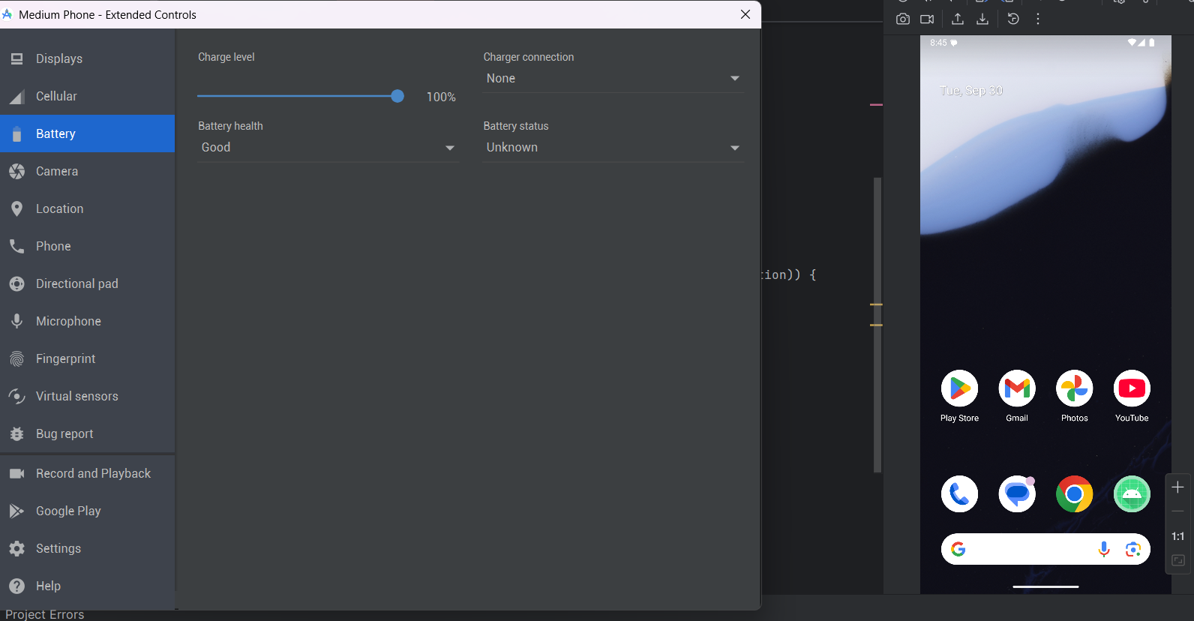

None 🡺AC charger



